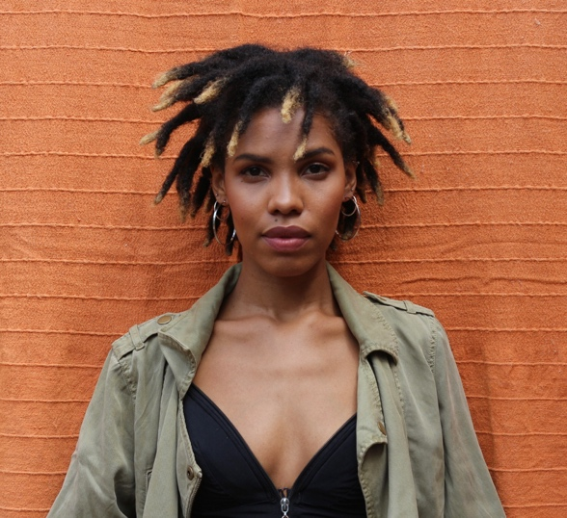
Lebogang Fisher
Age: 26
Gender: Female
Height: 165 cm, 5’5”
Eye colour: Brown
Hair colour: Brown/Black
Dress: 6 – 30/32
Bust: 32
Hips: 34
Waist: 28
Nationality: South African

____________________________________FILM__________________________________________
I-ris (2019) Lana/Supporting Dir. Leila Garrison (NYU Short)
Shell (2016) Birdy/Lead Dir. Raven Jackson (NYU Short)
Selah (2016) Selah/Lead Dir. Joseph Austin II (NYFA Short)
Choices (2015) Lead Dir. Joseph Austin II (NYFA Short)
Indecision (2015) Lead Dir. Joseph Austin II (NYFA Short)
Checkovian (2014) Robber 1/Supporting Dir. Natalia Korzanova (NYFA Short)

__________________________________TELEVISION______________________________________
Jungle/Amazon Studios (2021) Role: Florist
Lockdown Love (2021) Role: Kimberly
Troilus and Cressida :TSMGO(2020) Role: Cressida
Seven colours (2017) Role: Lihle
Solid 8: The Webseries ep "Background Pretty" (2016) Role: The DP

___________________________________THEATRE _______________________________________
Nothing on Earth (2023) Jade Dir. Rosamunde Hutt, Pursued by a Bear
Richard the Second (2022) Aumerle Dir. Anna Coombs, Tangle Theatre Co
Here’s What She Said To Me (2021) Aramide Dir. Mojisola Elujuwofo, Utopia
Hamlet (2020) Ophelia Dir. Neil Coppen, Fugard Theatre
Venus (2018) Ensemble Dir. Mpumi Khubeka, Rhodes
Skinned (2018) Lead Dir. Siphesihle Ndaba, NAF
Nkqo-Nkqo (2018) Latitha/Lead Dir. Upile Bongco, Rhodes
Living Colour (2017) Ensemble Dir./Choreo Carla Mostert, TIM
The swimming lesson (2017) Lead Dir. Mlondiwethu Dubazane, YDS
Qash-Qash (2017) Supporting Dir./Choreo Nomcebisi Moyikwa
Fantasy of Light (2016) The Queen/Ensemble Dir. Lizz Meiring, Waterfall Park
Twelfth Night (2016) Olivia Dir. Joe Raik, Monday Theatre Co. NYC
Death of a Barber (2015/2016) Shinta Douglas Dir. Les Ford, Nia Productions. NYC
Romeo and Juliet (2015) Juliet/Benvolio Dir. Joe Raik, Occupy Verona. NYC
Salomé (2015) The Jew Dir. Raymond Arnold, AlphaNYC Theatre
Breaking and Entering (2015) Lola Dir. Zac Hoogendyk, AMios NYC
Gruesome Playground Injuries (2014) Kayleen Dir. Greg Beam/Kim McKean, Union Sq.

_______________________________THEATRE (directing)__________________________________
Hamlet (2019) Shakespeare School’s Festival Off/Centre Theatre Co.
Masc(quee)rade (2019) Independent project (Co-director/choreographer)
Innovations (2019) Co-director Rhodes University
Titus Andronicus/The State (2018) Shakespeare School’s Festival Amazwe’ntombi Theatre Co.

____________________________COMMERCIAL_(Acting)___________________________________
EBAY (2023) “Jewellery Authentication” EBAY
KFC (2022/2023) “Table” KFC
Pasta Evangelists (2022) Unaired Pasta Evangelists/Mother
Uber (2022) “Benefits” Uber
From the Silver Screen (2021) “Film Firsts” For the Silver Screen
Avon (2015) “Be a breast friend” Avon Foundation for Women
Disney Channel (2013) Academic Girl (Lead) Star Productions

_____________________________________SHOWCASE ______________________________________
Warner Bros. Actors in Training Program Top Ten 2020
https://www.warnerbros.com/news/press-releases/warner-bros-television-actors-training-virtual-casting-initiative-introduces

Aspiring Rising Talent Showcase (June 2014) - Orlando, Florida
https://www.snl24.com/drum/News/young-pretoria-actress-heads-to-new-york-20170728

___________________________________TRAINING_______________________________________
BA Drama, English – Rhodes University (2017-2019). Voice, Movement, Physical Theatre, Acting, Directing
New York Film Academy (2014-2015) – one year acting for film conservatory: acting for film, audition technique, combat, speech, acting technique, Meisner
Indigo View Actor’s master classes with Steven Feinstein (2013-2014) – monologue, audition technique
Michelle Danner Master Class (2013) – Golden Box
Eve Ensler “I am an emotional creature” workshop (2012) – text analysis, performance structuring
The Barnyard Theatre: Melissa Lottering (2010 - 2012) – two year acting course

________________________________AWARDS__________________________________________
Warner Bros Top 10 Actors in Training 2020, top 10 Selection (2020)
https://deadline.com/2020/10/warner-brothers-television-casting-training-program-drama-students-coronavirus-1234605570/

Address Unknown: South African Film and Television Award Best Short Film 2020 /2021(Producer)
https://www.iol.co.za/weekend-argus/entertainment/address-unknown-wins-safta-award-for-best-short-film-b1ab1f5f-81d1-4c71-bb34-61295a4f0208

I-RIS: Audience Choice Award – Best Short Film 2019, Out for Blood Film Festival (UK)

________________________________SPECIAL SKILLS______________________________________
Accents: English RP, Southern American, West coast (Valley), Standard American; keyboard – Rock school grade 3; basic horseback riding; singing; swimming; softball; marimba; debating, Toastmasters international impromptu speaking.
*Valid driver’s license and passport.

