Fiona Sophia Cousineau
Fiona.cousineau@gmail.com
(581)-306-4835 / Montreal
23 years old
Height: 5’3’’
Weight: 115lbs
Hair: Black
Eyes: Brown

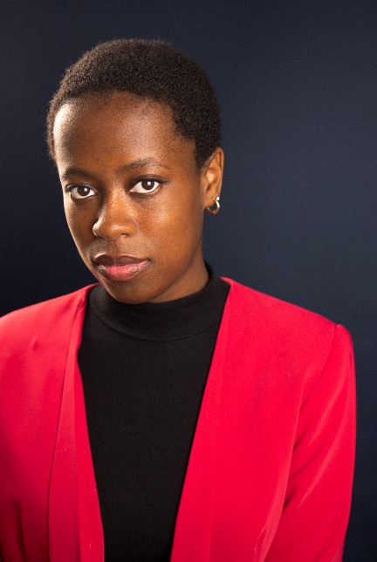

Theatre
Maric at the Lake | Meliva, Einstein | Concordia Theatre Program
Solo autobiographical piece | Wrote, directed, acted | Concordia Theatre Program
The Bareness and the pig | The Bareness | Concordia Theatre Program
Control | Narration | Fine Arts department
The Penelopaid | The Maid | Concordia Theatre Program
Alice in Wasteland | White Queen | Concordia Theatre Program
Les 21 Mésaventures D’Arlequin | Arlequin | École Dominique Racine, Chicoutimi, QC

Training
BFA, Acting for Theatre program , Concordia University, 2021
Acting –Concordia Theatre program, Robert Reid, Harry Standjofski, Noah Drew, Montreal
Voice – Concordia Theatre program speech/ dialect / singing ~ Laura Quigley, Shannon Holmes, Noah Drew (needs more detail, what when)
Movement – Stage Combat / View Points / Biomechanics / Decroux technic ~ Jean-Francois Gagnon, Leslie Baker, Robert Reid, Denise Boulanger
Music – Piano/Guitar/Saxophone ~ École de musique de Chicoutimi, when.
Dance- Ballet/Jazz/Hip hop / Flamenco/ Contemporary/ Gigue / Folklore / Gumboots ~ Les Farandoles, Chicoutimi, QC 2002 – 2018

Skills
Languages: Bilingual both English and French
Accents: French / British
Activities: Tennis, Soccer, Skiing
Other: Full drivers license

