SABIRA STANISAVLJEVIC

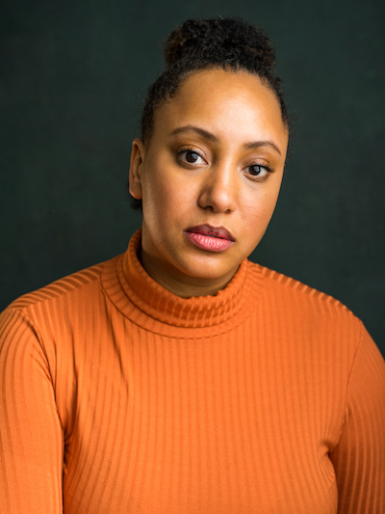
Playing Age Range: 27 – 35
Height: 5ft 8”
Location: West London
Native Accent: British RP
DBS Checked | Equity Member
sabira.stanisavljevic@gmail.com | +44 (0) 7468 434 516
https://www.mandy.com/actor/profile/sabira-stanisavljevic

London born and raised, Sabira Stanisavljevic has trained under theatre actor, Laurence Mitchell and at Identity School of Acting.

Her passion lies in telling stories, whether that be through someone else's scripts or her own, she wants to give a voice to the characters that society may have forgotten, or just don't know anything about as yet. Sabira’s desire to work on projects that explore complex relationships as well as shine a light on how socio-economic situations affect the people around us, has seen her work across theatre, TV and film.

CREDITS

FILM
“Carrie” In Plain Sight, 2020 (in production)
“Becka” Whispers, 2020 (in production)

THEATRE
“Call Me By My Name” – Applecart Arts Theatre, London and online 2020
“Scene’s with Girls” - ID Theatre, London 2020
“Carla” in The Wasp – JB Production 2019
“Kendra” in American Son – JB Production 2019
“Connie” in The Effect Home Studios Productions, 2018
“Prudence” in Beyond Therapy, 2011

TV
“Sandy” The Thursday Club – DH Productions, 2020 (in production)
“Ella” 100% Fubu – JB Productions, 2019

COMMERCIALS
“Boxer” in 100 Years and Counting – Channel, 2018
Boots commercial, 2012

OTHER
“Assistant Director” in Music Video, “Brain Dead” by Piero Pirupa, 2020
Non-speaking part in Bollywood movie Mira (The Girl on The Train), 2019

Skills
Boxing* | Rock Climbing* | Road Cycling / Mountain Biking* | Surfing | Horse Riding

Accents
RP* | General American* | Southern American | New York | Cockney | Liverpool/Scouse* | Yorkshire

*Expert

