Ewa Dina
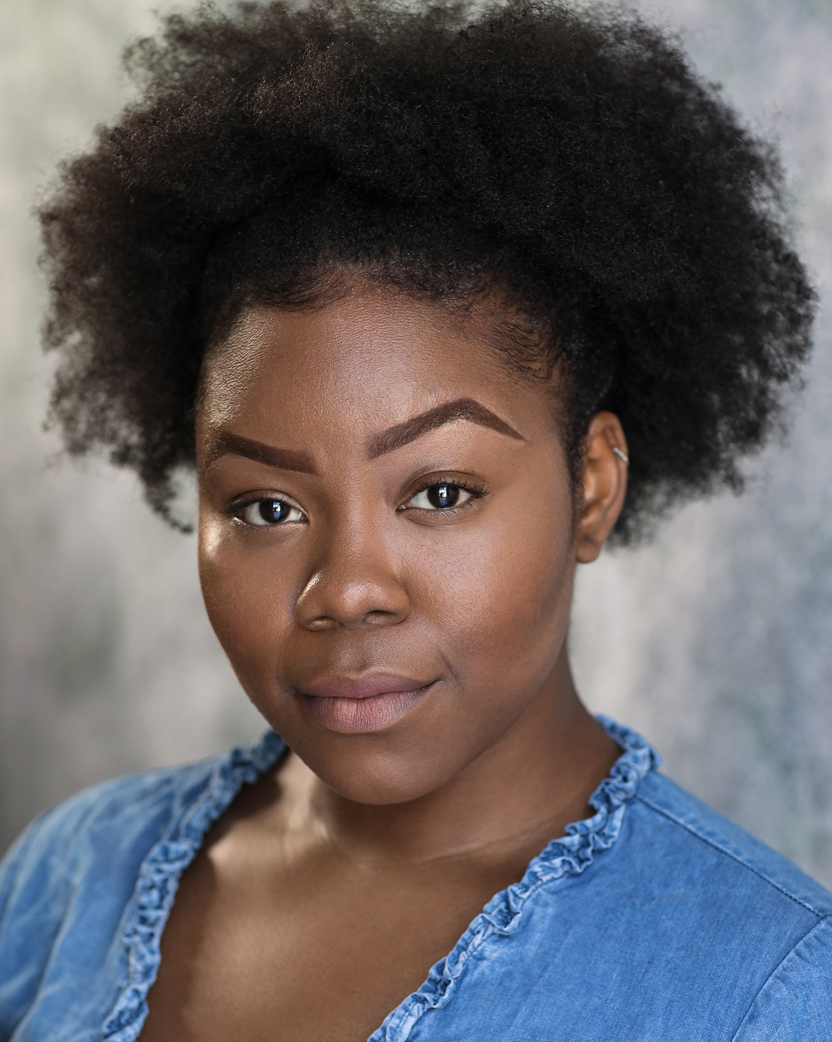

Insert picture here

Mobile: 07480828548
Email: dina97.ed@gmail.com
Equity: A00457828
Spotlight: 1974-5642-8453

Height: 5’ 7’
Eyes: Dark Brown
Hair: Black

Training:

Rose Bruford College
National Youth Theatre of Great Britain

Theatre - Acting
Production | Role | Director | Venue/Company | Length of Run | Year of Performance
How We Love | Regi | Robbie Taylor Hunt | VAULTS Festival  Airlock Theatre | 18th – 23rd Feb | 2020
One Flew over the Cuckoo’s Nest | Rachael Paulette McMurphy | Derek Anderson | The English Theatre, Frankfurt | 28th August – 19th October | 2019
Custody (UK Tour) | SISTER | Gbemisola Ikumelo | Belgrade Theatre, Coventry  Malcolm X Community Centre, Bristol  Studio, Sheffield Theatres  Lawrence Batley, Coventry  Oval House Theatre, London  The Art Machine & Prime Theatre | Tour: Monday 29 April - 31 May  Oval House Dates: Monday 3 - Saturday 22 June | 2019
The Suicide (Adapted By Suhayla El-Bushra) | Sarah | Karen Tomlin | Stratford Circus  Rose Bruford College | 11th March – 13thMarch | 2019
Virtue | Kemi | Brigitte Adela | Southwark Playhouse  Full Disclosure | 5th October 2018 | 2018
Run It Back | Auntie Mi/Various Roles | Coral Messam | The Hackney Showroom  Talawa Theatre Company | 29th August – 31st August | 2018
Romeo & Juliet | Ensemble | Jonathan Humphrey | The Crucible – Sheffield Theatres | 17th September – 17th October | 2015
Pride & Prejudice | Ensemble | Tamara Harvey | Sheffield People’s Theatre  The Crucible – Sheffield Theatres | 14th May – 06thJune | 2015
Camelot: The Shining City | Ensemble | Alan Lane | Slung Low & Sheffield People’s Theatre  The Crucible – Sheffield Theatres | 09th July – 18thJuly | 2015
Hacktivists | Tania | - | Easy Street  The Studio – Sheffield Theatre | 28th March 2015 | 2015
Sheffield Mysteries | Ensemble | Daniel Evans | Sheffield People’s Theatre  Crucible – Sheffield Theatres | 15th July – 19thJuly | 2014

Theatre - Directing
Production | Role | Venue/Company | Length of Run | Year of Performance
Sunnymead Court | Assistant Director | The Actors Centre | 22nd September – 3rd October | 2020
The Kola Nut Does Not Speak English | Director | VAULTS Festival  Nouveau Riche | 10th – 22nd March | 2020
Ribbons (Excerpt) | Director | Lion & Unicorn Theatre  Bloom Theatre | 7th March – 8thMarch | 2020
Foremother  (Excerpt) – Rehearsed Reading | Director | Lone Star Dinner  Bush Theatre | 20th November | 2019
Omish | Director | The Courtyard Theatre  Lunar Entertainment | 6th November – 24th November | 2018
Route | Director | The Hope Theatre  Bread & Roses Theatre  Tristan Bates Theatre  Blacktress Festival (Tristian Bates Theatre) | Hope:  29th – 30th July  Bread & Roses:  19th – 20th August  Tristan Bates:  28th August – 1stSeptember  Blacktress:  15th October & 18th October | 2018

Accents/Dialects: American-African American, American-Southern States, American-Standard, Leeds, Manchester, Sheffield* (Yorkshire) (native), Multicultural London English (MLE), Caribbean, Jamaican, Nigerian* (native), RP

Skills: Ballet – basic, Netball, Contemporary Dance, Street dance, commercial dance, Waltz, Period Dance, Caribbean dance, Dancehall, Modern Dance, African Dance*, Choreography teacher*, good eye for choreography, swimming, Spoken word artist, percussion, yoga, presenter, Director, Workshop leader

Musical Skills: Harmony Singing, Gospel Singing, Deep Contralto

